**Ideation Phase**

**Brainstorming & Idea Prioritization**

|  |  |
| --- | --- |
| Date | 19 September 2022 |
| Team ID | PNT2022TMID50825 |
| Project Name | Project – Personal Expense Tracker Application |
| Maximum Marks | 4 Marks |

**Brainstorm & Idea Prioritization Template:**

Brainstorming provides a free and open environment that encourages everyone within a team to participate in the creative thinking process that leads to problem solving. Prioritizing volume over value, out-of-the-box ideas are welcome and built upon, and all participants are encouraged to collaborate, helping each other develop a rich amount of creative solutions.

**Step-1: Recognising the general structure of the application**

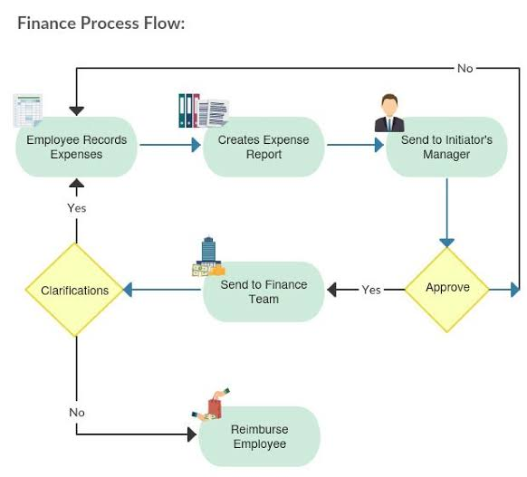

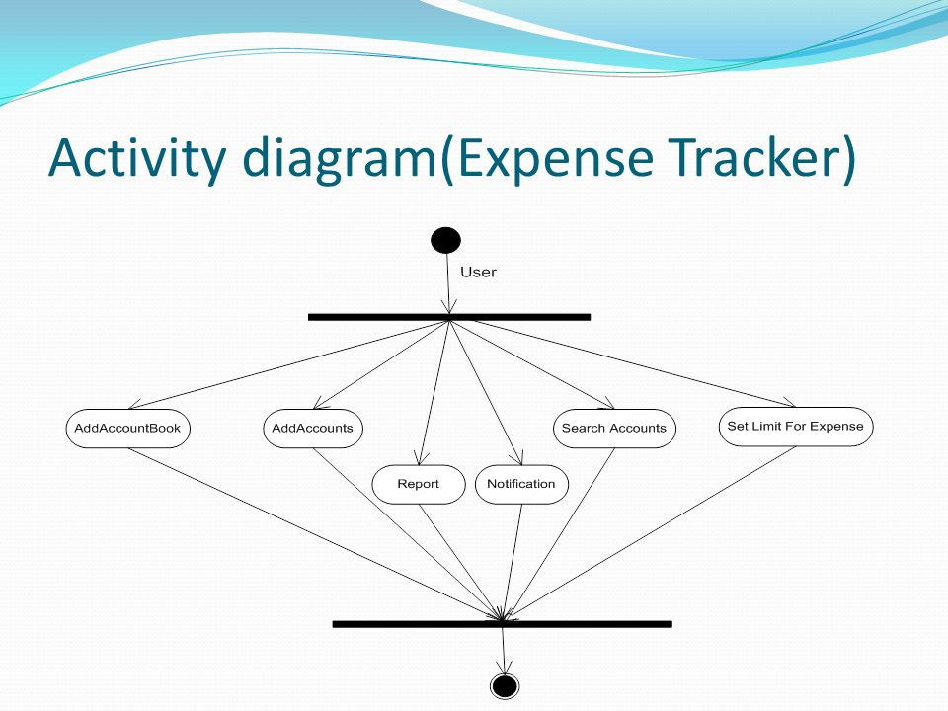**Step-2: Listing the activities involved and brainstorm them**

**Step-3: Idea Prioritization of main functions**

